BABY GRAMPS
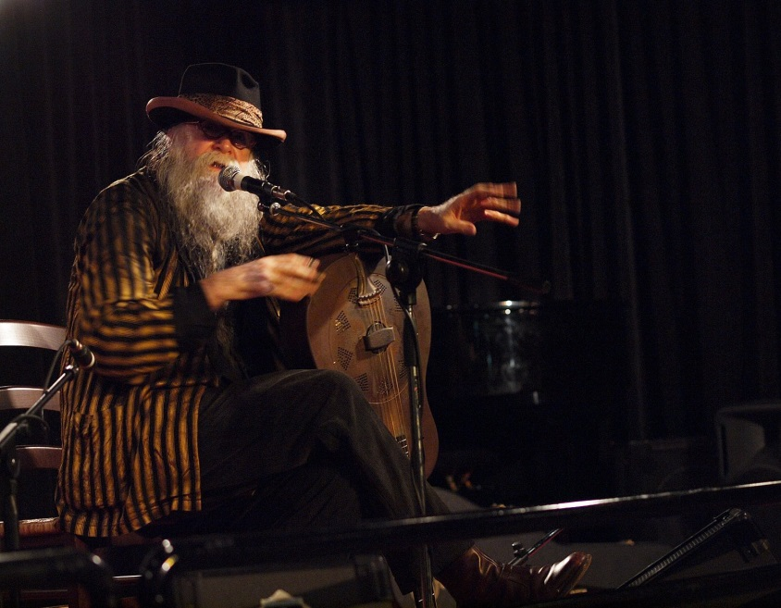
"The Salvador Dali of Folk Music"
Baby Gramps is an energetic humorously entertaining performer with an endless repertoire. He plays a National Steel guitar, and sings his own unique arrangements of rags, jazz, & blues from the 20's & 30's, and many originals with wordplay, humor, and throat singing.
According to an article in Seattle Metropolitan Magazine, Baby Gramps is acknowledged as one of the top 50 most influential musicians in the last 100 years.
This past year Baby Gramps was asked to be part of three films. One is a documentary about the history of jugband music, another is an update of the academy award nominated film Streetwise that he performed some music for 30 years ago, and the third is 50 Feet of Film that includes a new original song about the homeless.
Baby Gramps toured Australia, England, and Ireland as part of the Rogues Gallery CD Concert Tour with Tim Robbins (actor), Marianne Faithful, Lou Reed, Martin Carthy, Suzanne Vega, Ralph Steadman, and many other internationally known performers. The Rogues Gallery CD, produced by Johnny Depp and Hal Willner in connection with The Pirates of the Caribbean film, landed Baby Gramps on the David Letterman Show accompanied by Tony Garnier, Bob Dylan’s band leader and bass player.
More info, song clips, and videos can be found at www.babygramps.com

